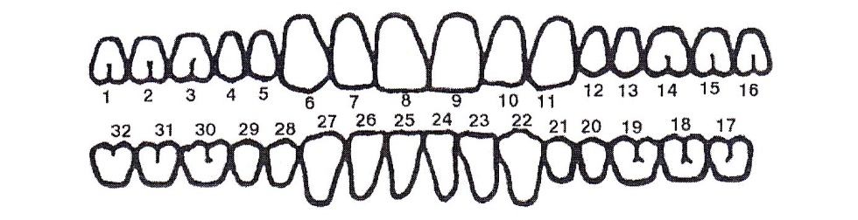

RESTORATION: SPECIAL INSTRUCTIONS:

Zi Prettau Click or tap here to enter text.

Zi Prettau Layered

Zi Prettau Anterior

Lithium Disilicate

Lith. Disil. Layered

PFM*

FGC

Implant S/R Zi Prettau

Implant S/R PFM

Other Click or tap here to enter text.

*FOR PFM’S ONLY:

No metal to show Buccal Y N 360 No Metal to show Y N

Metal Lingual Collar Y N Metal Occlusal / Lingual Y N

360 Metal Collar Y N Porcelain Butt Joint Margin Y N

Dr. Signature _____________________________ Lic # ________________

PREP DATE

Click or tap here to enter text.

DUE DATE

Click or tap here to enter text.

*Dentist: Click or tap here to enter text.

*Patient: Click or tap here to enter text.

*TOOTH #: Click or tap here to enter text.

20816 N 20th Avenue Ste 5

Phoenix AZ 85027

623-463-0100

Email: pdai2015@gmail.com



SHADE: Click or tap here to enter text.